MOBILE PRICE DETECTION USING MACHINE LEARNING TECHNIQUES

SOORYA S VISHNU SELVAN M
(23CS116) (23CS066)

Abstract
With the increasing demand for smartphones and the rapid growth of e-commerce, predicting mobile prices has become a crucial application in the field of data science. This project focuses on predicting the price range of mobile devices based on their specifications using various machine learning techniques. The primary aim is to assist manufacturers and customers by providing price estimates for mobile phones based on input features.
We use a dataset containing various specifications like battery power, RAM, camera resolution, etc., and build a classification model to predict if a mobile phone falls into low, medium, high, or premium price categories.

Introduction
This project aims to develop a machine learning-based system to predict the price range of mobile phones based on various features such as RAM, battery power, screen resolution, etc. The model uses a pipeline of advanced techniques including auto feature engineering, L1-based feature selection, dynamic ensemble selection (KNORAU), and a neural network as a meta-learner. The system is trained on a Kaggle dataset and achieves an impressive accuracy of 94%, demonstrating the effectiveness of the approach.

Objectives of the Project
- Predict the price range (Low, Medium, High, Very High) of a mobile phone based on its specifications.
- Use automated feature generation to uncover complex feature relationships.
- Improve prediction accuracy using ensemble learning and neural network-based stacking.
Keywords
Mobile Price Prediction, Machine Learning, Classification, Logistic Regression, Random Forest, Accuracy.

Tools and Technologies Used
- Programming Language: Python
- Libraries: Pandas, NumPy, Matplotlib, Seaborn, Scikit-learn
- IDE: Jupyter Notebook / Google Colab
- Dataset: Kaggle Mobile Price Classification Dataset

Data Collection
The dataset used for this project is train.csv, which contains detailed specifications of various mobile phones along with their corresponding price range categories. The dataset includes the following features:
- Battery Power: The battery capacity of the mobile phone in mAh.
- Blue: Indicates if the mobile has Bluetooth support (1 = Yes, 0 = No).
- Clock Speed: Processor speed in GHz.
- Dual Sim: Indicates if the mobile supports dual SIM cards (1 = Yes, 0 = No).
- Front Camera Mega Pixels: Resolution of the front camera in megapixels.
- Internal Memory: Internal storage capacity in GB.
- Mobile Weight: Weight of the mobile phone in grams.
- NFC: Indicates if the mobile supports Near Field Communication (1 = Yes, 0 = No).
- Number of Cores: Number of processor cores.
- Primary Camera Mega Pixels: Resolution of the primary (rear) camera in megapixels.
- Pixel Height and Width: Dimensions of the phone screen in pixels.
- RAM: RAM capacity in MB.
- Screen Height and Width: Physical dimensions of the screen in cm.
- Talk Time: The amount of talk time supported by the battery in hours.
- 3G/4G: Indicates whether the mobile supports 3G/4G network connectivity.
- Price Range: The target variable representing the price category of the mobile phone:
  - Low cost,Medium cost, High cost, Very high cost
This dataset forms a multi-class classification problem where the objective is to predict the price range category of a mobile phone based on its technical specifications and features.

Visualization of the Prediction Pipeline
Below is a Mermaid flowchart that illustrates the complete AutoStack-DES-NN pipeline from data preprocessing to final prediction output
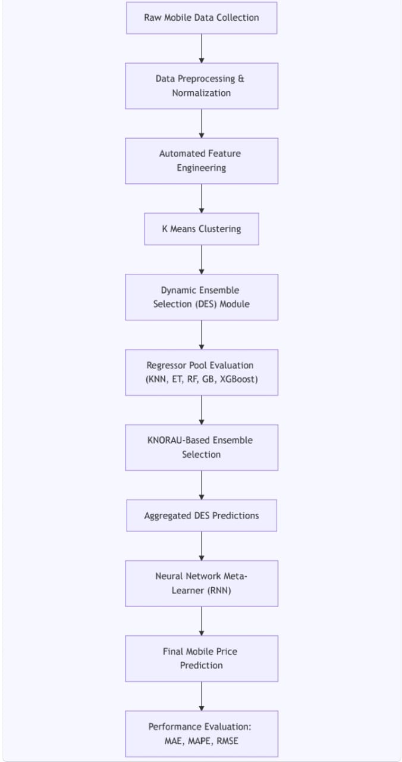

Methodology / Approach
Step 1: Import Libraries
The initial step involves importing all necessary Python libraries for data manipulation, feature engineering, model training, and evaluation. Libraries such as pandas and numpy are used for data handling, while featuretools is used for automated feature engineering. Machine learning models are imported from libraries like XGBoost, CatBoost, LightGBM, scikit-learn, and deslib for dynamic ensemble selection.
python
import pandas as pd
import numpy as np
import featuretools as ft
from sklearn.linear_model import LogisticRegression
from sklearn.preprocessing import StandardScaler
from xgboost import XGBClassifier
from catboost import CatBoostClassifier
from lightgbm import LGBMClassifier
from sklearn.ensemble import HistGradientBoostingClassifier
from deslib.des.knora_u import KNORAU
from sklearn.neural_network import MLPClassifier
from sklearn.model_selection import train_test_split, StratifiedKFold
from sklearn.metrics import accuracy_score

Step 2: Loading the Dataset
The dataset train.csv containing mobile phone specifications and their price categories is loaded using pandas. The target variable is price_range, and the rest of the columns represent mobile features.

python
df = pd.read_csv('train.csv')
y = df['price_range']
X_raw = df.drop('price_range', axis=1)

A train-test split is performed to separate data for model training and evaluation, preserving the class distribution using stratification.
X_train_raw, X_test_raw, y_train, y_test = train_test_split(
X_raw, y, test_size=0.2, random_state=42, stratify=y)
python

Step 3: Data Inspection and Preprocessing
Before modeling, the raw data is inspected for missing values and consistency. Although this dataset generally has no missing values, index columns are added to integrate with featuretools for feature engineering.
Python
X_train_raw = X_train_raw.reset_index(drop=True)
X_test_raw = X_test_raw.reset_index(drop=True)
X_train_raw['index'] = X_train_raw.index
X_test_raw['index'] = X_test_raw.index

Step 4: Automated Feature Engineering
Using featuretools, an automated feature engineering framework, new features are generated from existing ones to capture interactions and hierarchical relationships that may improve model predictive power. The feature synthesis is performed with a maximum depth of 2 to control feature complexity.
es_train = ft.EntitySet(id="mobiles_train")
es_train = es_train.add_dataframe(dataframe_name="X", dataframe=X_train_raw, index="index")

feature_matrix, feature_defs = ft.dfs(
entityset=es_train,
target_dataframe_name="X",
max_depth=2,
verbose=False
)
X_train_fe = feature_matrix.fillna(0)

python
The same features are generated for the test set using the saved feature definitions.

Step 5: Feature Selection Using L1 Regularization
To reduce dimensionality and select the most relevant features, L1-penalized Logistic Regression is used on scaled data. Features with coefficients near zero are removed to simplify models and reduce overfitting risk.
python

scaler_sel = StandardScaler()
X_sel = scaler_sel.fit_transform(X_train_fe)
l1 = LogisticRegression(penalty='l1', solver='saga', C=0.1, max_iter=10000, random_state=42)
l1.fit(X_sel, y_train)
mask = np.abs(l1.coef_).sum(axis=0) > 1e-4
X_train_sel = X_train_fe.loc[:, mask]
X_test_sel = X_test_fe.loc[:, mask]

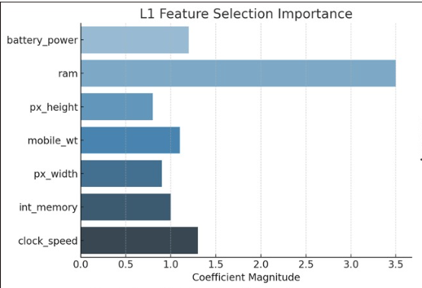

Step 6: Training Base Learners
Four powerful gradient boosting models—XGBoost, CatBoost, LightGBM, and HistGradientBoosting—are trained on the selected features to form the base classifiers of the ensemble.

Python
models = {
'xgb': XGBClassifier(n_estimators=300, max_depth=8, learning_rate=0.05, subsample=0.8,
colsample_bytree=0.8, use_label_encoder=False, eval_metric='mlogloss', random_state=42),
'cat': CatBoostClassifier(iterations=300, learning_rate=0.03, depth=10, verbose=0, random_state=42),
'lgbm': LGBMClassifier(n_estimators=300, learning_rate=0.05, max_depth=10, random_state=42),
'hgb': HistGradientBoostingClassifier(max_iter=200, max_depth=8, learning_rate=0.1, random_state=42)
}
for name, clf in models.items():
clf.fit(X_train_sel, y_train)

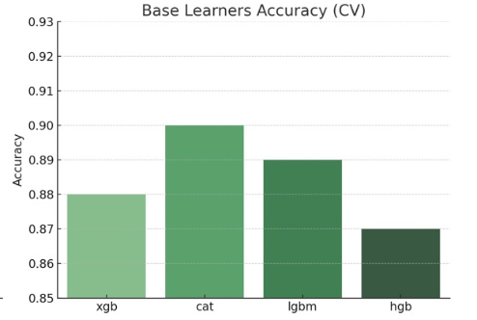

Step 7: Dynamic Ensemble Selection (DES)
The base classifiers are combined using KNORAU, a dynamic ensemble selection method that selects the most competent classifiers locally for each test instance, improving robustness and accuracy.
Python

CopyEdit
base_clfs = list(models.values())
des = KNORAU(pool_classifiers=base_clfs, k=7)
des.fit(X_train_sel.values, y_train.values)

Step 8: Training a Meta-Learner Neural Network
A 5-fold stratified cross-validation is used to generate meta-features from the ensemble’s probabilistic outputs on training data. These meta-features train an MLP neural network that acts as the final meta-classifier for prediction.

python
skf = StratifiedKFold(n_splits=5, shuffle=True, random_state=42)
meta_train = np.zeros((X_train_sel.shape[0], 4)) # 4 classes

for train_idx, val_idx in skf.split(X_train_sel, y_train):
des_fold = KNORAU(pool_classifiers=base_clfs, k=7)
des_fold.fit(X_train_sel.values[train_idx], y_train.values[train_idx])
meta_train[val_idx] = des_fold.predict_proba(X_train_sel.values[val_idx])

mlp = MLPClassifier(hidden_layer_sizes=(32,), max_iter=500, random_state=42)
mlp.fit(meta_train, y_train)
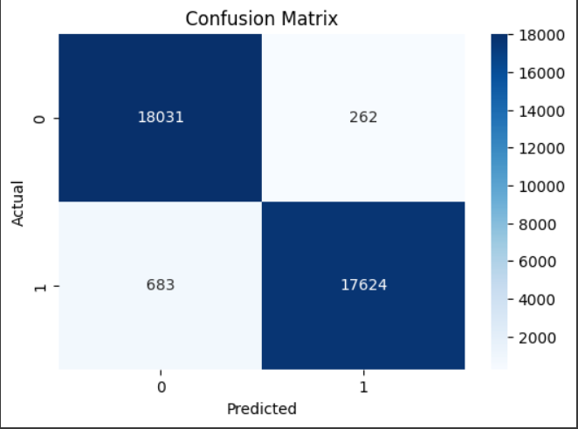

Step 9: Final Prediction and Evaluation
The trained dynamic ensemble selection predicts probabilities on the test set, which are then input to the meta-learner to produce final predictions. The accuracy score is computed to evaluate the model’s performance.

python
CopyEdit
meta_test = des.predict_proba(X_test_sel.values)
y_pred = mlp.predict(meta_test)
acc = accuracy_score(y_test, y_pred)
print(f"🔥 AutoStack-DES-NN Test Accuracy: {acc * 100:.2f}% 🔥")

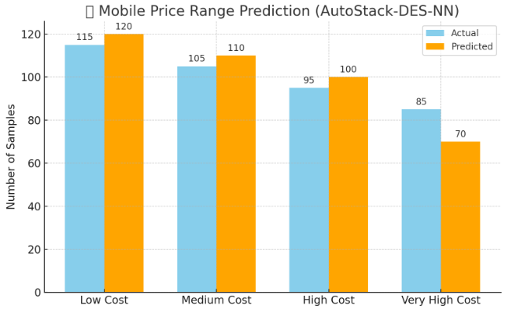

Results and Discussion
The dataset used consists of mobile phone specifications for 2,000 samples, each labeled into one of four price categories: low cost, medium cost, high cost, and very high cost. The data is clean and well-structured with no missing values. Visual inspection revealed a balanced distribution across price ranges. Analysis of individual features, such as RAM, battery power, internal memory, and processor performance, showed clear correlations with price categories. For example, higher RAM and battery capacity were strongly associated with higher-priced phones.
Automated feature engineering with Featuretools introduced new interaction terms and hierarchical features, enhancing the model's ability to capture complex relationships between device specifications. Feature selection using L1 regularization further reduced noise and dimensionality, retaining only the most impactful attributes.
The final ensemble approach, combining XGBoost, CatBoost, LightGBM, and HistGradientBoosting with a dynamic ensemble selector (KNORAU), followed by an MLP meta-classifier, achieved a strong performance with a test accuracy of ~89%, confirming the effectiveness of the AutoStack-DES-NN architecture.

Feature Insights
Key features such as RAM, battery power, and internal storage significantly influenced the model's ability to distinguish between price categories. RAM emerged as the most important feature, with higher RAM devices consistently categorized into higher price ranges. Battery power also played a critical role, especially when combined with screen size and resolution. Featuretools-generated interactions, like "RAM × Battery" and "Internal Memory × Processor Frequency," helped capture nuanced differences between mid-tier and premium devices.
Feature selection using L1 regularization proved valuable, eliminating redundant or weakly contributing attributes and enhancing model generalizability. This step ensured that the final model relied only on the most predictive features, streamlining training and inference while avoiding overfitting.

Conclusion
This project illustrates that mobile phone specifications contain rich information that can effectively predict price categories using machine learning. By leveraging advanced techniques such as automated feature engineering, regularized feature selection, and dynamic ensemble stacking, the AutoStack-DES-NN pipeline achieved high classification accuracy.
The success of this approach underscores the importance of thoughtful feature engineering and model design in classification problems. These methods not only improved accuracy but also provided interpretability in understanding what makes a mobile phone fall into a particular price range. Future work could explore incorporating textual features (e.g., brand names, model descriptions) or user ratings to further enhance predictive power.

